Besides system & algorithm design, testing and debugging. In the past few months I mainly take part in 3 sections within the project: VLC player plug-in implement investigation and development, system Library Development and Client-side application Development.

VLC player plug-in Development

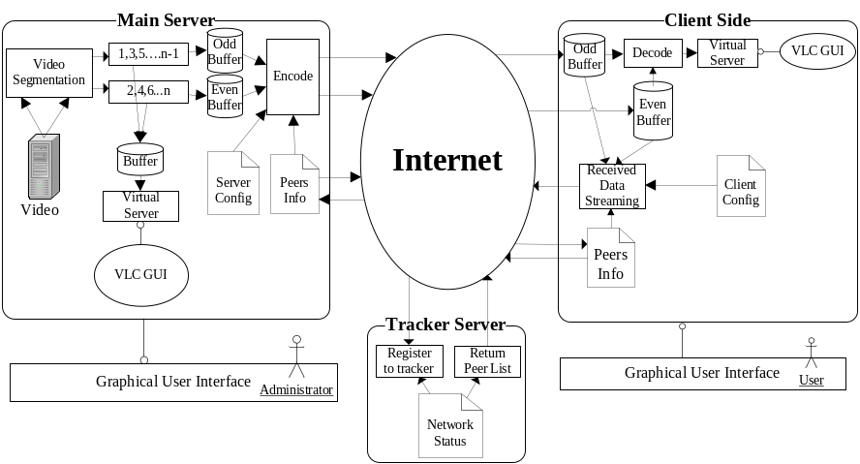
Just at the beginning of our project, we have tried to develop the whole system by our own. We have developed the GUI interface with Windows Media Player Plug-in. Develop the encoding/decoding algorithm for streaming out and play.

However, with the advice of Prof. Danny Tsang, we start to investigate the possibility of develop the system with VLC plug-in. After reading certain related documents and browsing certain Technical Forum. We found that VLC player plug-in would be an excellent tool that can provide us great convenient to develop the P2PIPTV system.

The role of VLC player in our new design is act as the end application within the system. It will decode/encode the video file for streaming and play by its build-in programs. As a result, we can pay more attention in the main purpose of our project – build up the P2P IPTV, but not encoding algorithm.

System Library Development
Since lots of settings and users’ preference need to set/change within the system depends on various conditions. We design a GUI page for user to set/modify specific settings.

To store these setting and data, I develop a program to convert these data into XML file format. XML file can be view and edit easily which provide us great convenient for review purpose.

Client side Application Development
After the success of 1-to-many client-server model implementation, we start to pay our attention into develop our P2P system.

In our design, we have to set up a tree structure before to implement any P2P algorithm. We have to set up a tree structure of peers’ connection for the system. So we further develop our client-side application, make it from a simple video receiver and player into upload video at the same time that it download. Make new clients can join to the old clients as role of sub-client, so form a tree structure.

